Day 29 – 30th August – 113195064 – Bondili Bhavya Charitha
Task:1 – Installation Process of No SQL – WorkBench – Done
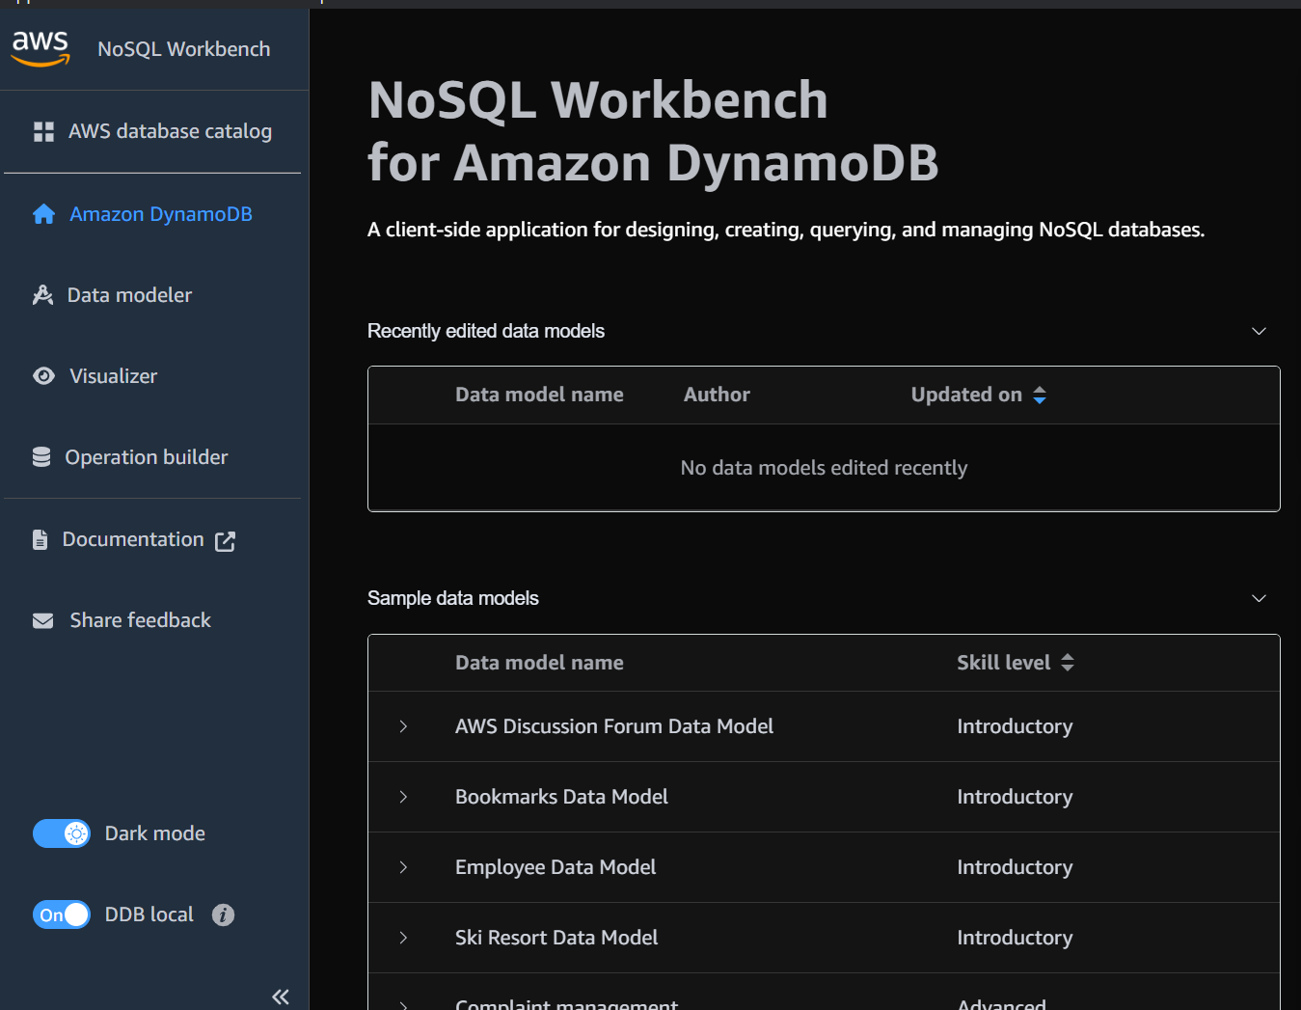

Task:2- Create a table in NoSQL workbench – DynamoDB
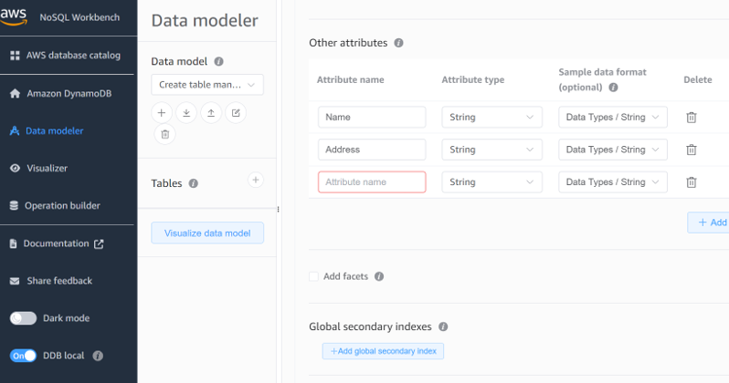
Task:3 –
Different Connections established.
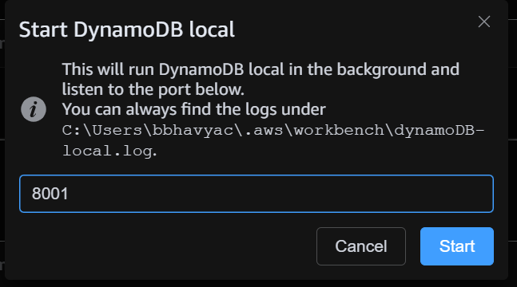

Task:4 – AWS CLI – Done
